26.3: For resistors in series, the currents are the same and the voltages add. a) true. b) false. c) 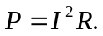 i same, R different so P different; false. d) true. e) V = IR. I same, R different; false. f) Potential drops as move through each resistor in the direction of the current; false. g) Potential drops as move through each resistor in the direction of the current, so 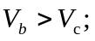 false. h) true.

